1.**Introduction**

Keerthi Sweets a Manufacturer and Trader of Sweets, relies on Zoho Books to manage their inventory, Handle purchase orders, and generate invoices for their customers. They can track stock levels, Manage supplier payments, and generate financial reports. Zoho Books helps them streamline their Wholesale operations and optimize inventory management.

Keerthi Sweets is a renowned manufacturer and trader of delectable sweets, catering to both wholesale And retail customers. With a rich heritage spanning several decades, Keerthi Sweets has earned a Reputation for its commitment to quality, authenticity, and customer satisfaction. Specializing in a wide Variety of traditional and innovative sweets, they combine traditional recipes with modern techniques To create flavors that tantalize taste buds.Keerthi Sweets is a Private Limited company also registered under GST in Tamil Nadu.

2.**Purpose**

Zoho Books is very helpful to one-stop platform for managing our accounting tasks and organizing our company transactions. It’s a single secure location to keep up with our company’s bills and invoices, reconcile your bank statements, control our spending, oversee projects, and eliminate sales tax compliance worries.

3.**Problem Definition And Design Thinking**

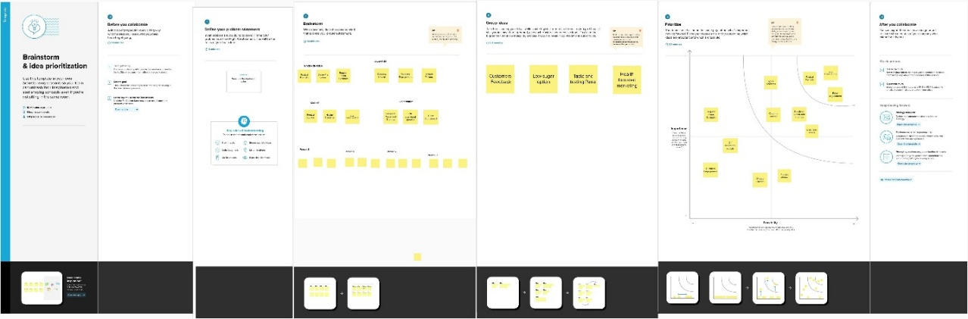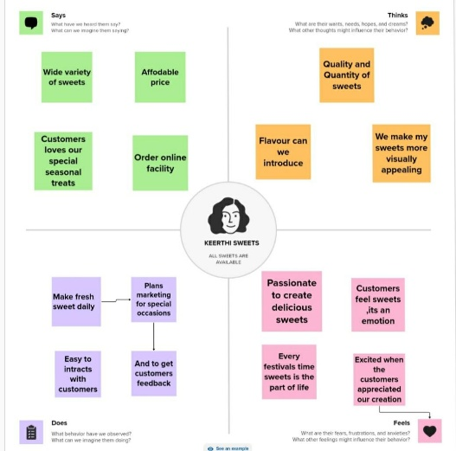

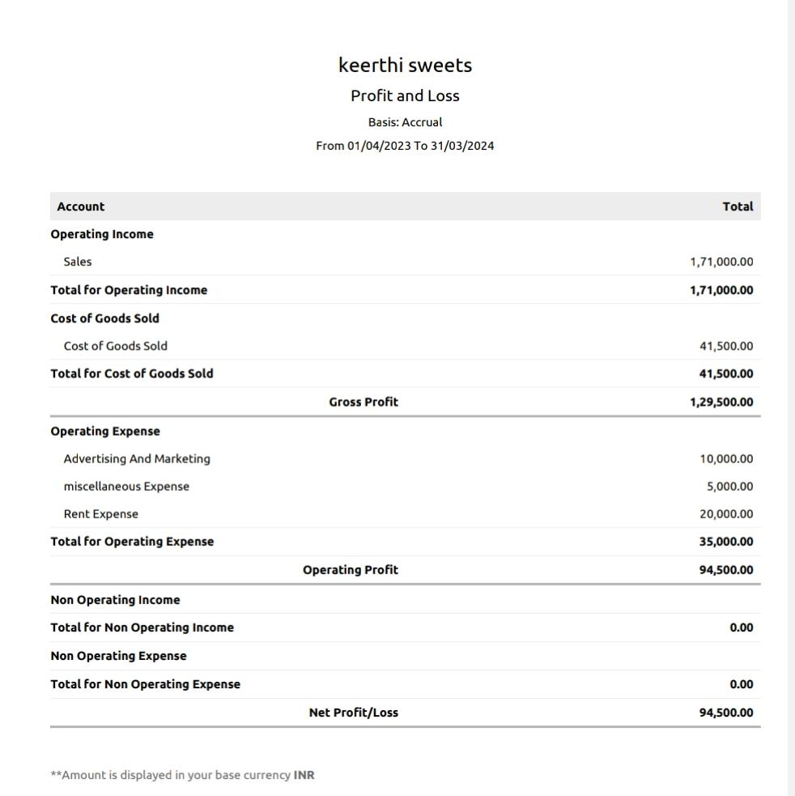

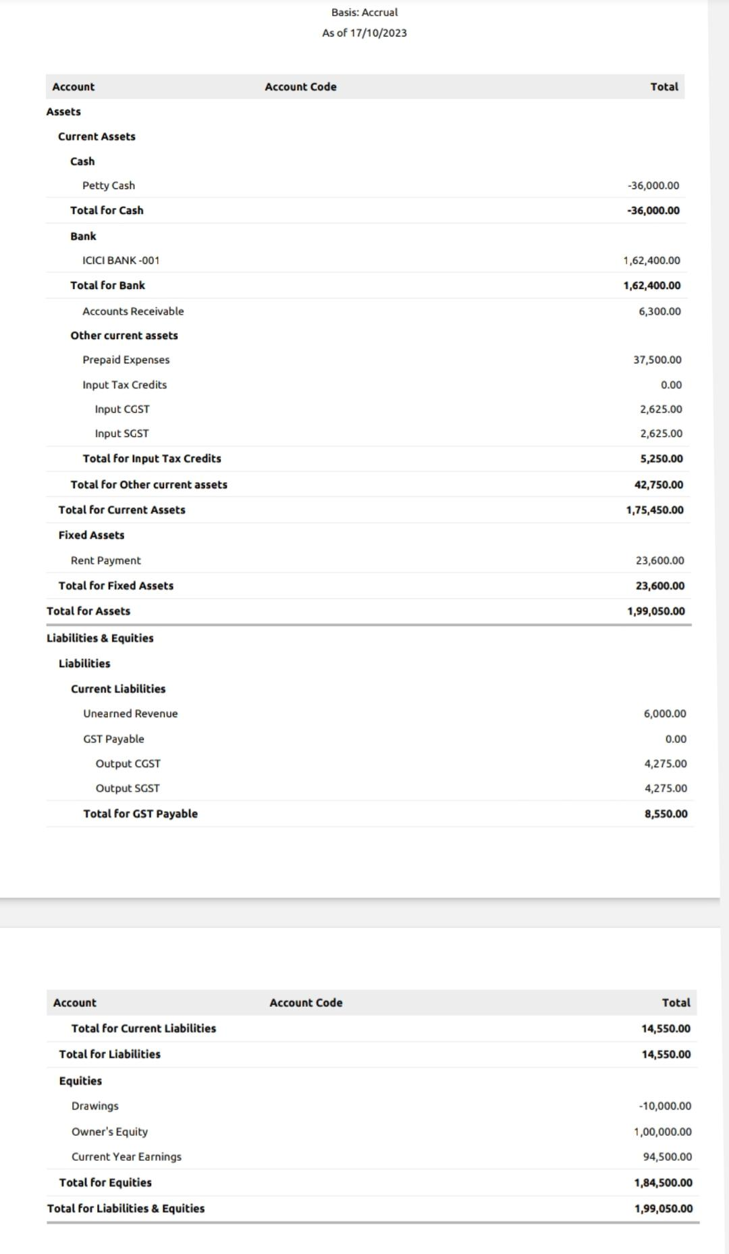

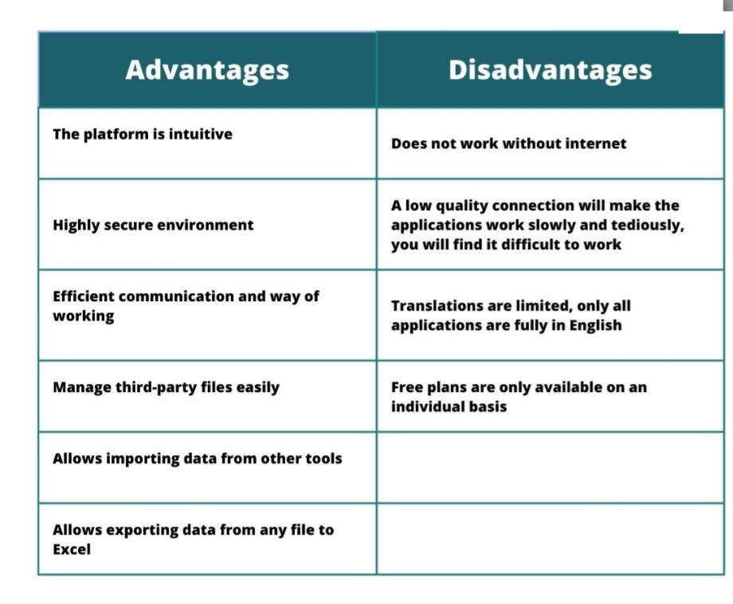**Advantages and Disadvantages:**

**Conclusion:**

Zogo books is easy to understand and its configuration is quick and easy,